**TOPIC: Identify New Bikes**

|  |  |
| --- | --- |
| **TEAM MEMBERS** | |
| **NAME** | **EMPLOYEE ID** |
| KIRTAN GAJJAR | 2234444 |
| KUNAL KUMAR | 2234542 |
| MERIN CYRIAC | 2234478 |
| RASHMI PATEL | 2235257 |
| SHLOK BARUAOLE | 2234443 |
| VEDIKA KAMDI | 2234485 |

## Table of Contents

Table of Contents ii

Table Of Figures iii

1 WEBSITE 1

2 REQUIREMENTS 2

2.1 Problem Statement: Identify New Bikes 2

2.2 Detailed Description: 2

2.3 Key Automation Scope: 2

3 TOOLS AND TECHNOLOGIES USED: 3

3.1 Selenium with Java in Eclipse IDE 3

3.2 TestNG: 3

3.3 Maven: 3

3.4 WebDriverManager- Boni García 3

3.5 Apache POI 4

3.6 ExtentReports 4

4 SCREENSHOTS: 5

4.1 Upcoming Bikes Under 4 Lakhs 5

4.2 Popular Models of Used Cars in Chennai 9

4.3 Login with Google 11

## Table Of Figures

Figure 1.1 Landing Page: zigwheels.com 4

Figure 4.1.1 Dropdown box appears after hovering the cursor on” New Bikes” menu. 8

Figure 4.1.2 Hyperlink text is functioning by clicking on upcoming bikes 8

Figure 4.1.3 Manufactures dropdown menu appears after clicking on upcoming bikes 9

Figure 4.1.4 Select Honda brand from the list of manufactures 9

Figure 4.1.5 User has to click on “View More Bikes” option 10

Figure 4.1.6 Remaining bike list is displayed when user clicks on “View More Bikes” option 10

Figure 4.1.7 User is redirected to homepage after clicking on” Zig wheels” logo from upcoming bikes section 11

Figure 4.2.1 Dropdown appears when user hovers cursor over “Used Cars” in navigation bar 12

Figure 4.2.2 User selects "Chennai" from the drop down options 12

Figure 4.2.3 User is redirected to "Used Cars in Chennai" page 13

Figure 4.2.4 List of Popular Model in used car in Chennai is displayed. 13

Figure 4.3.1 User clicks on "Login/Signup" Button 14

Figure 4.3.2 Login popup appears when user clicks on ’login/signup’ button 14

Figure 4.3.3 New login window appears when user clicks on ’Continue with Google’ button 15

Figure 4.3.4 When user enters valid and registered email id and clicks ’Next’ button 15

Figure 4.3.5 When user enters an unregistered email id with valid format and clicks ’Next’ button 16

Figure 4.3.6 When user enters an invalid email id format and clicks ’Next’ button 16

Figure 4.3.7 When user enters unregistered but valid format phone number and clicks ’Next’ button 17

Figure 4.3.8 When user enters invalid phone number (Too short) and clicks ’Next’ button 17

Figure 4.3.9 When user enters invalid phone number (Too long) and clicks ’Next’ button 18

Figure 4.3.10 When user enters incorrect password and clicks ’Next’ button 18

# WEBSITE

URL: <https://www.zigwheels.com/>

Title: [New Cars & Bikes, Prices, News, Reviews, Buy & Sell Used Cars - ZigWheels.com](https://www.zigwheels.com/)

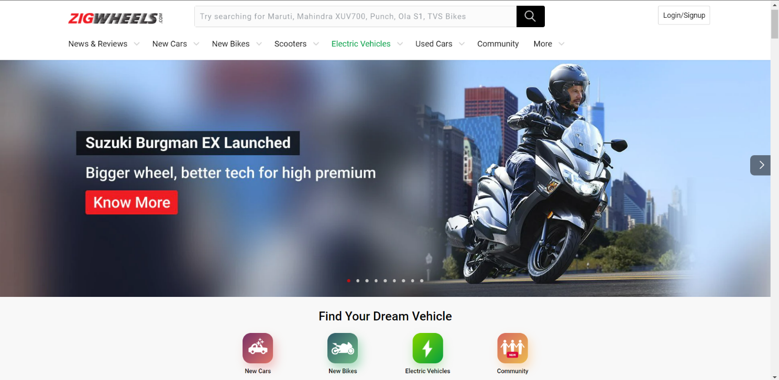

Figure 1.1 Landing Page: zigwheels.com

# REQUIREMENTS

## Problem Statement: Identify New Bikes

Display upcoming bikes details like, bike name, its price and expected launch date in India  
1. Manufacturer should be Honda.  
2. Bike price should be less than 4Lac

## Detailed Description:

1. Display "Upcoming" bikes details like bike name, price and expected launch date in India, for manufacturer 'Honda' & Bike price should be less than 4Lac.
2. For Used cars in Chennai, extract all the popular models in a List; Display the same
3. Try to 'Login' with google, give invalid account details & capture the error message (Suggested site: zigwheels.com however you are free to use any legitimate site)

## Key Automation Scope:

* Handling windows & frames
* Filling simple form, Capture warning message
* Extract menu items from frames & store in collections
* Navigating back to home page

# TOOLS AND TECHNOLOGIES USED:

## Selenium with Java in Eclipse IDE

Selenium is one of the most renowned open-source test automation frameworks.

Selenium Framework is used in this project to interact directly with the browsers through automation testing scripts written in JAVA.

## TestNG

TestNG is an automation testing framework in which NG stands for “Next Generation”.

In this project, TestNG is used to create, control and the execute the all the test cases. Annotations and attributes in TestNG are used to define the dependency, description and prioritization of test cases. It is also supporting the data-driven testing.

## Maven

Maven is a built automation tool from Apache Software Foundation and is commonly used to handle Java projects. It is widely used to manage project dependencies and the whole lifecycle of any project. Maven uses the concepts of the project object model (POM) and enables the user to cut down several steps followed in the build process.

Maven builds a project using its project object model (POM) and a set of plugins. Once you familiarize yourself with one Maven project, you know how all Maven projects build. This saves time when navigating many projects.

## WebDriverManager- Boni García

WebDriverManager is an open-source Java library that carries out the management (i.e., download, setup, and maintenance) of the drivers required by Selenium WebDriver (e.g., chromedriver, geckodriver, msedgedriver, etc.) in a fully automated manner.

WebDriverManager provides a fluent API available using the class WebDriverManager (package io.github.bonigarcia.wdm). This class provides a group of static methods to create *managers*, i.e., objects devoted to providing automated driver management and other features.

## Apache POI

Apache POI, where POI stands for (Poor Obfuscation Implementation) is an API that offers a collection of Java libraries that helps us to read, write, and manipulate different Microsoft files such as excel sheets, power-point, and word files.

In this project, Apache POI has been implemented to make the test cases data driven, by importing input test data from EXCEL document.

## ExtentReports

ExtentReports is a logger-style reporting library for automated tests. A logger is simply an object to log messages or events for a specific system or application. ExtentReports uses the logging style to add information about test sessions, such as creation of tests, adding screenshots, assigning tags, and adding events or series of steps to sequentially indicate the flow of test steps.

In this project ExtentReports has been used to keep a track of success status (PASS/FAIL/SKIP) of each automated test case, and create a report on the same. This HTML report contains pie chart representation, test stepwise report generation, adding screenshots etc., at every test step and a presentable user interface that can be shared with all stakeholders of the project.

# SCREENSHOTS:

## Upcoming Bikes Under 4 Lakhs

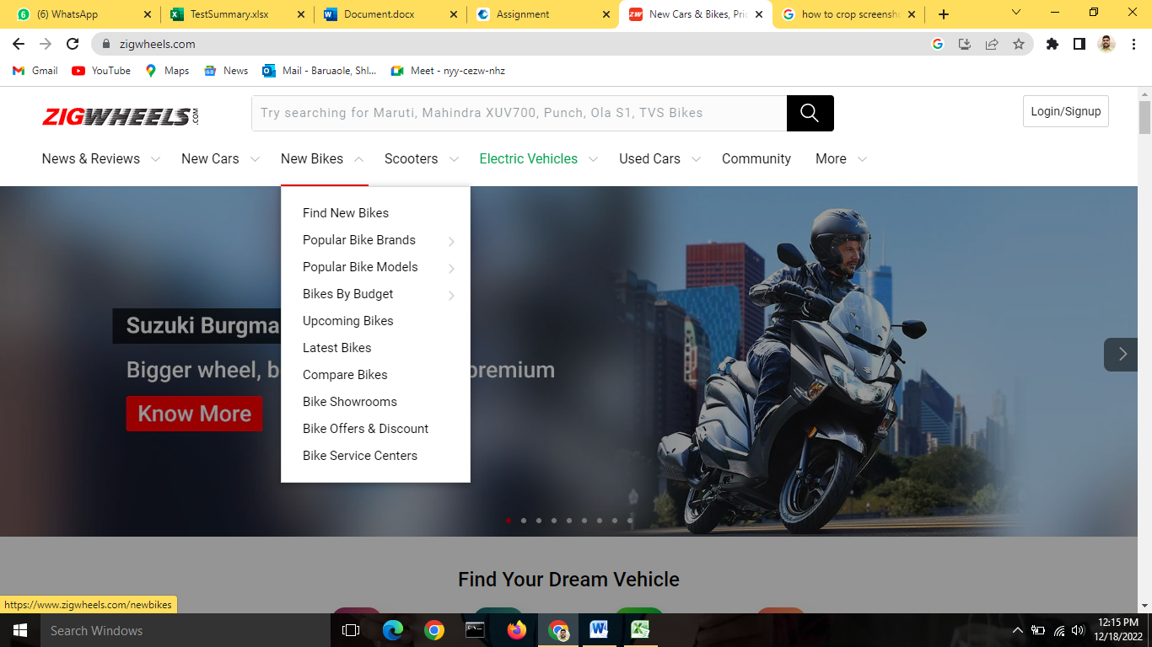

Figure 4.1.1 Dropdown box appears after hovering the cursor on” New Bikes” menu.

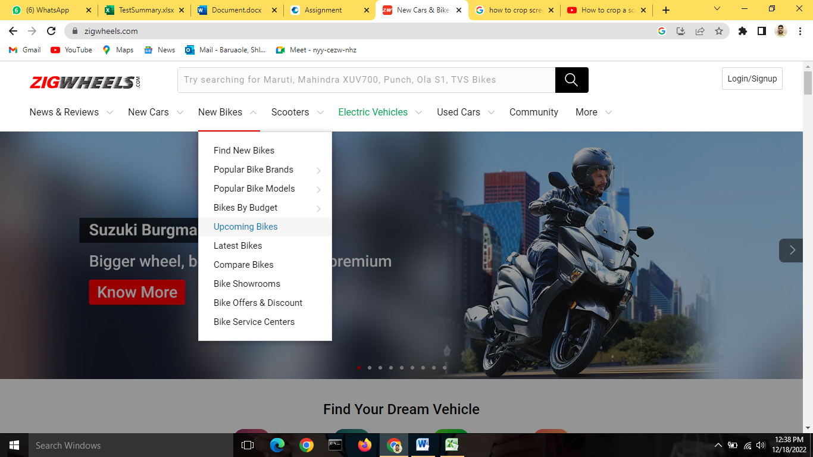

Figure 4.1.2 Hyperlink text is functioning by clicking on upcoming bikes

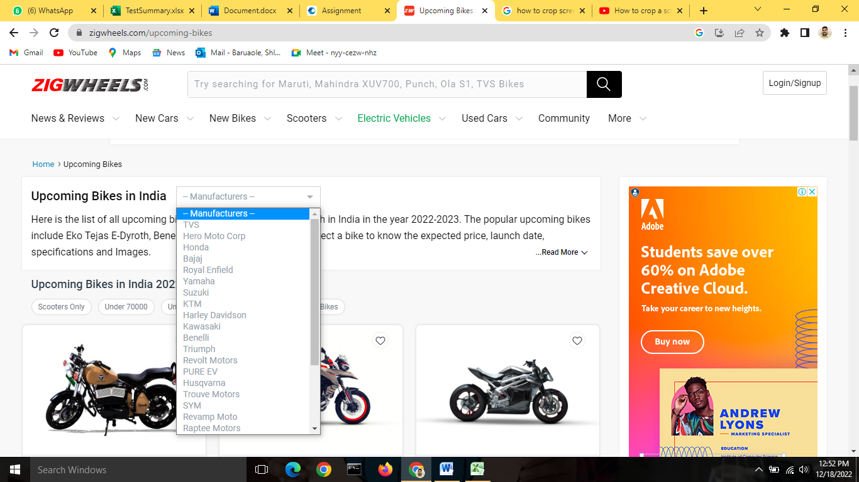

Figure 4.1.3 Manufactures dropdown menu appears after clicking on upcoming bikes

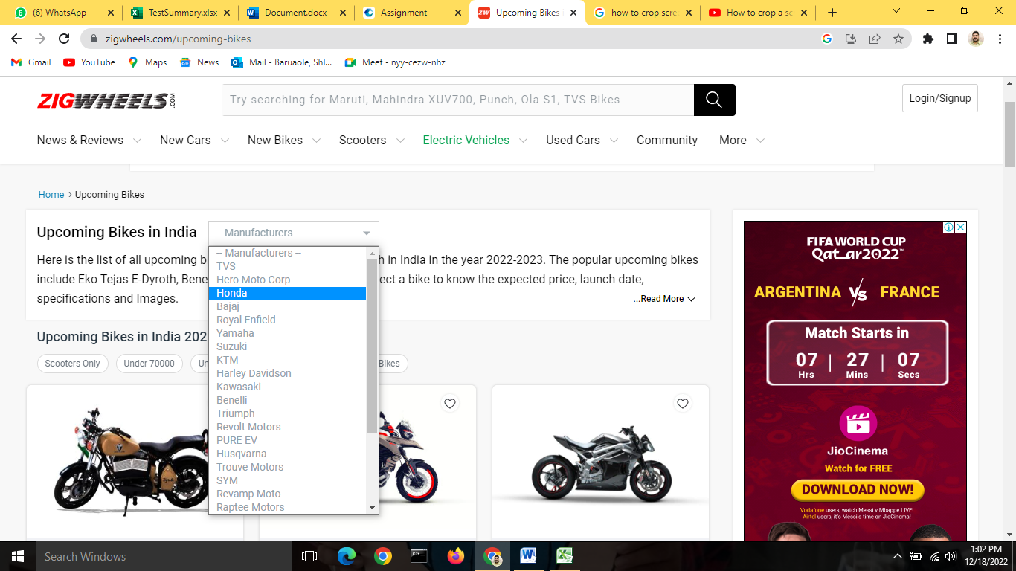

Figure 4.1.4 Select Honda brand from the list of manufactures

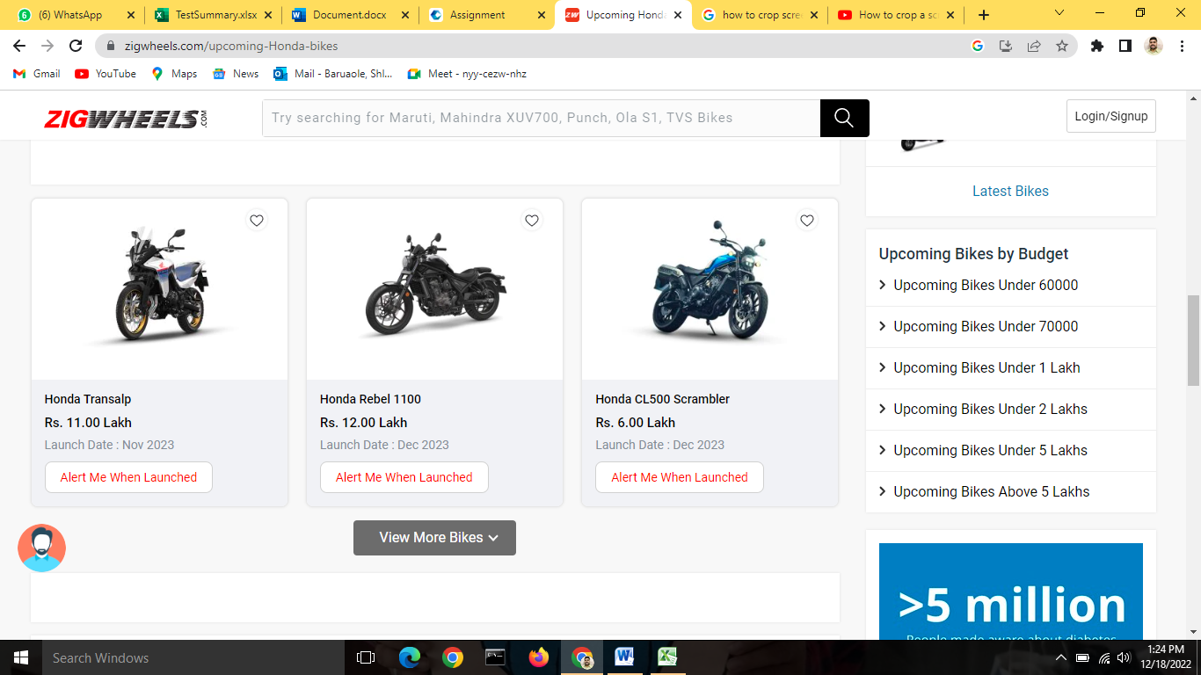

Figure 4.1.5 User has to click on “View More Bikes” option

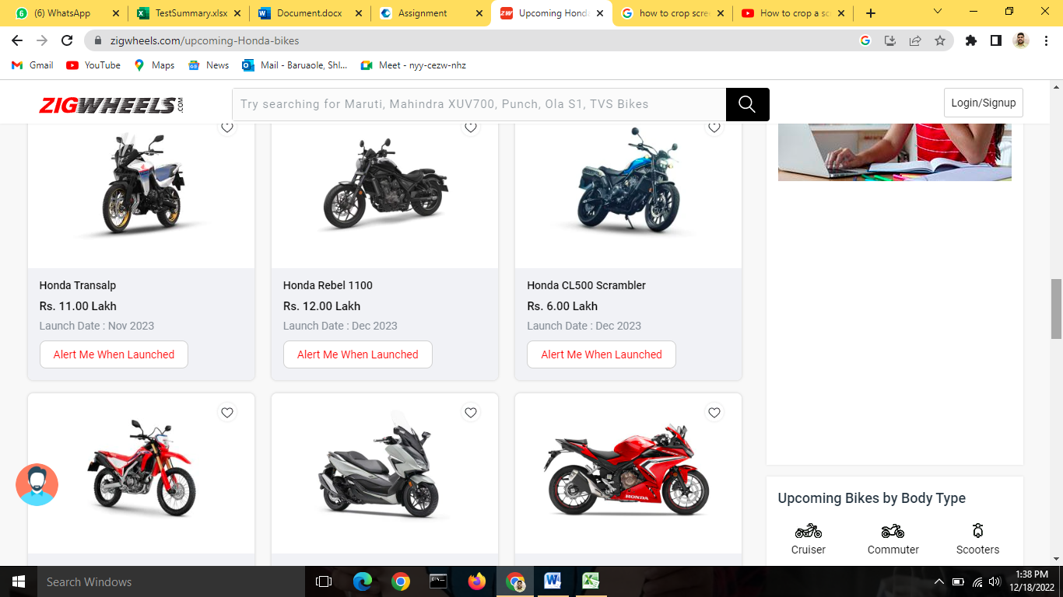

Figure 4.1.6 Remaining bike list is displayed when user clicks on “View More Bikes” option

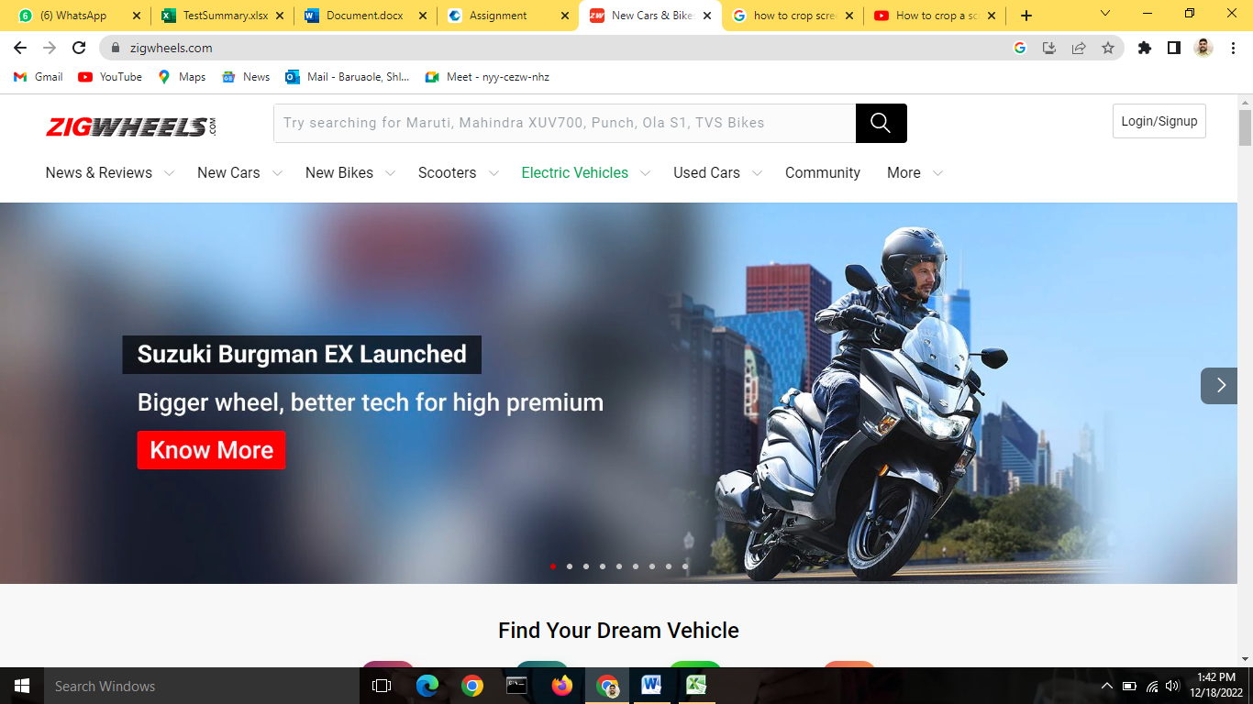

Figure 4.1.7 User is redirected to homepage after clicking on” Zig wheels” logo from upcoming bikes section

## Popular Models of Used Cars in Chennai

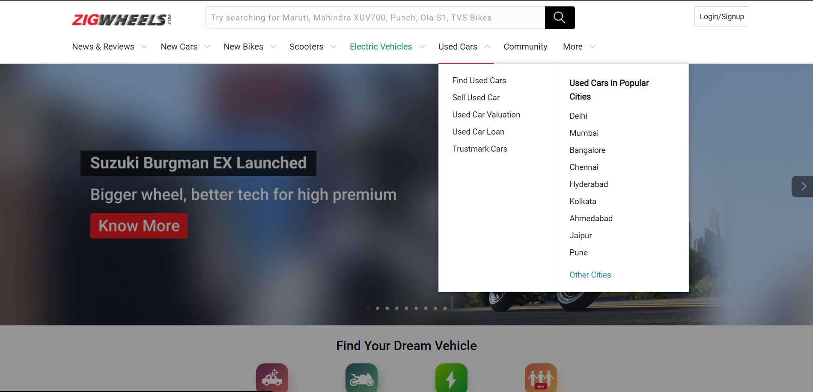

Figure 4.2.1 Dropdown appears when user hovers cursor over “Used Cars” in navigation bar

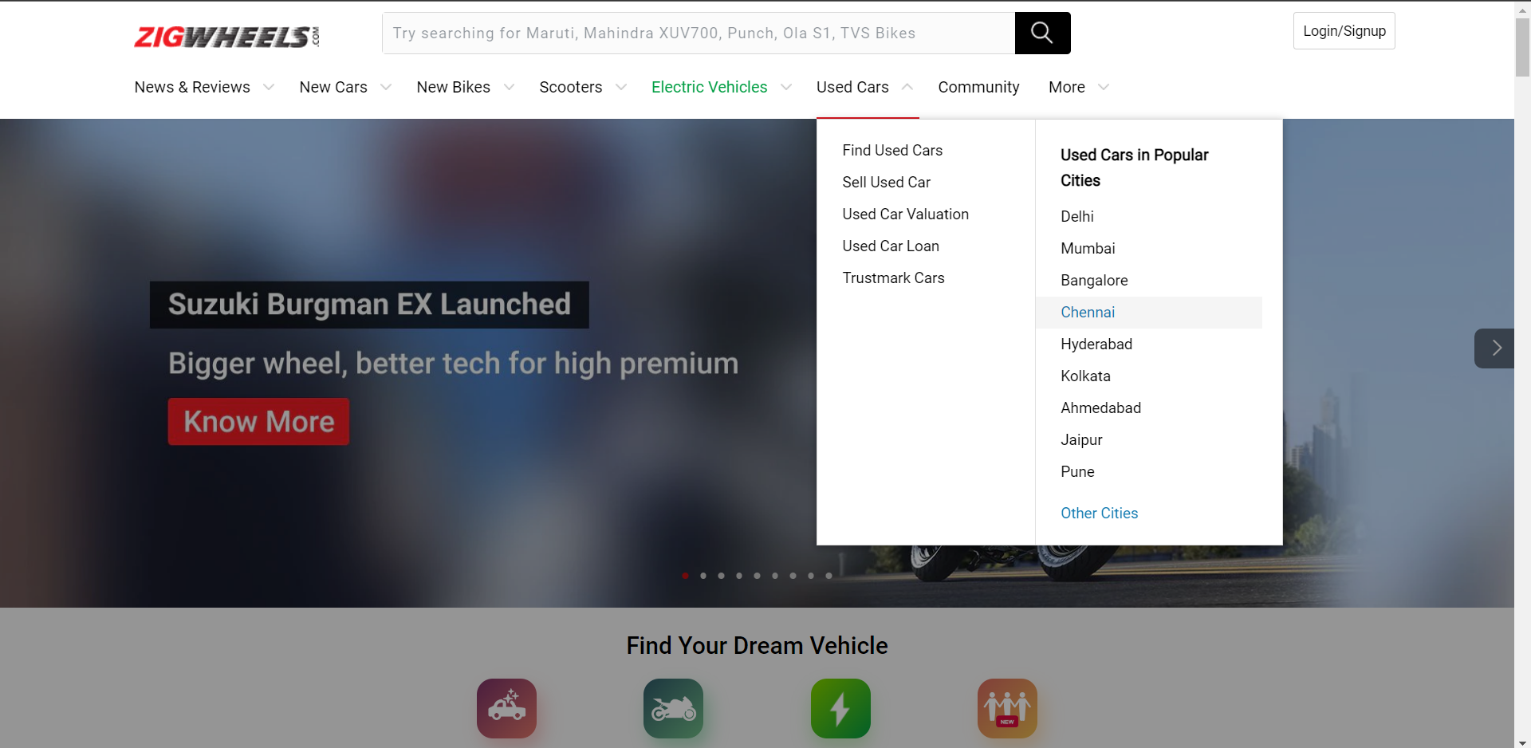

Figure 4.2.2 User selects "Chennai" from the drop-down options

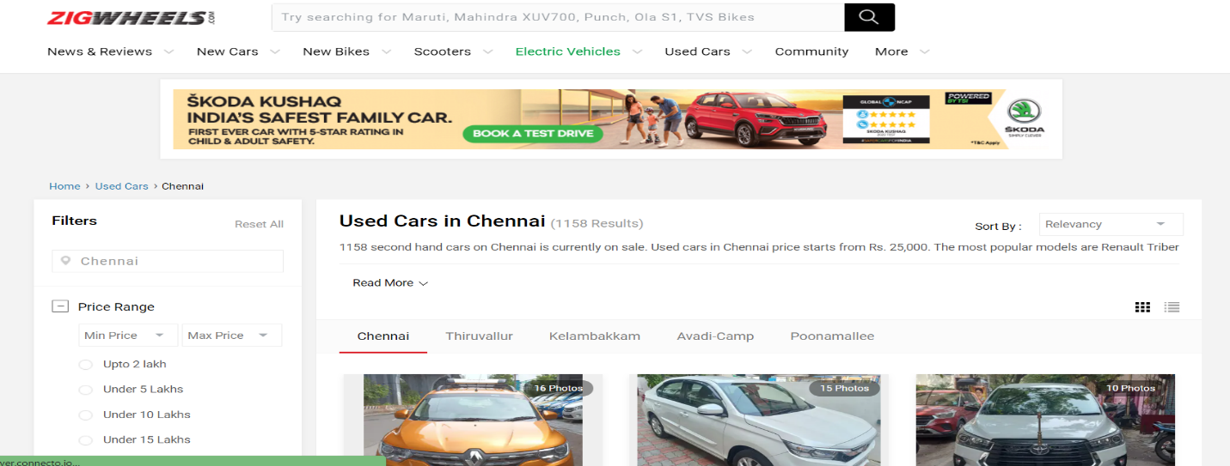

Figure 4.2.3 User is redirected to "Used Cars in Chennai" page

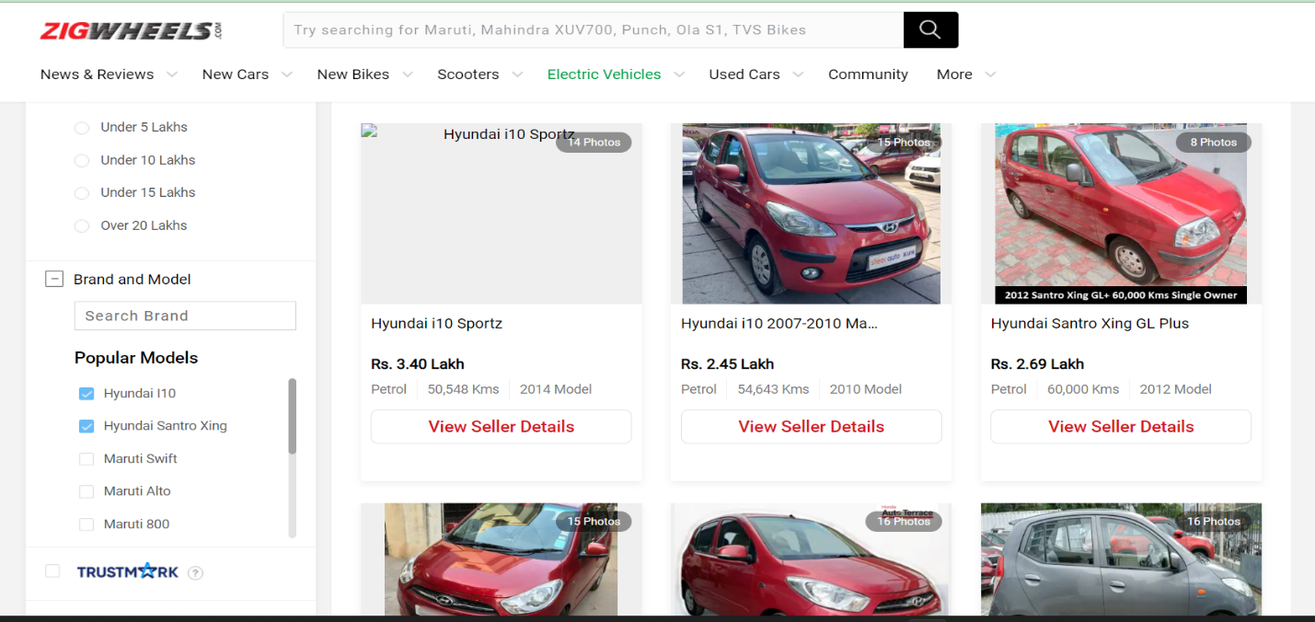

Figure 4.2.4 List of Popular Model in used car in Chennai is displayed.

## Login with Google

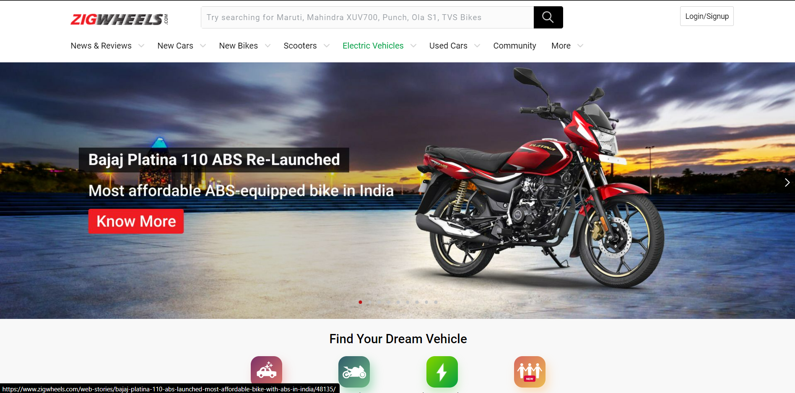

Figure 4.3.1 User clicks on "Login/Signup" Button

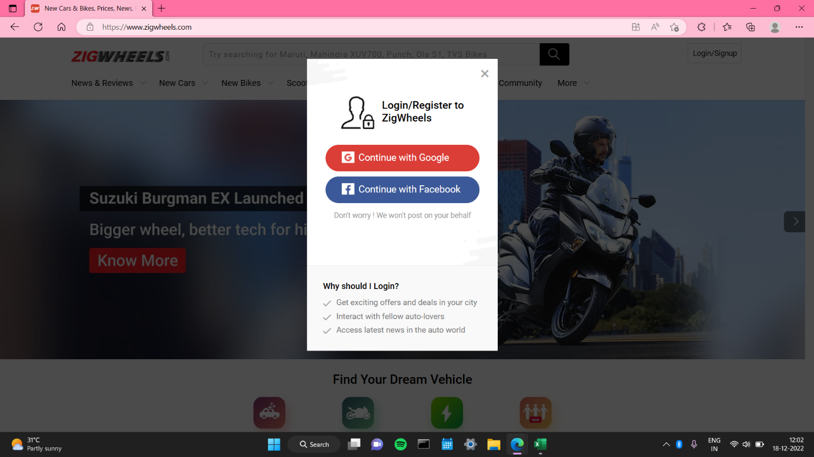

Figure 4.3.2 Login popup appears when user clicks on ’login/signup’ button

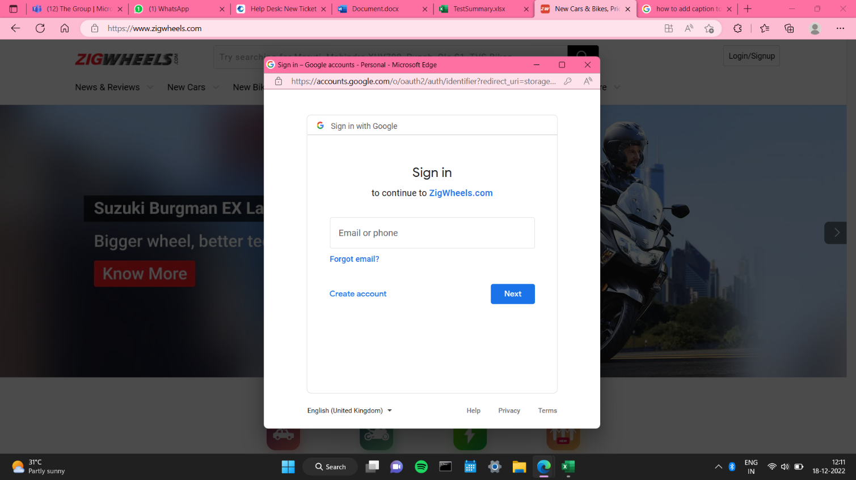

Figure 4.3.3 New login window appears when user clicks on ’Continue with Google’ button

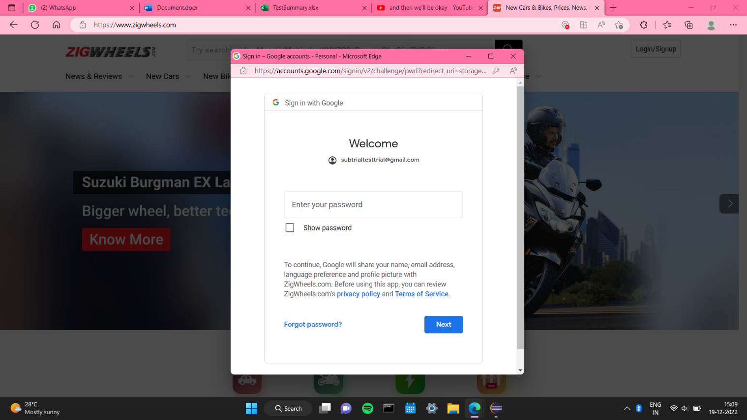

Figure 4.3.4 When user enters valid and registered email id and clicks ’Next’ button

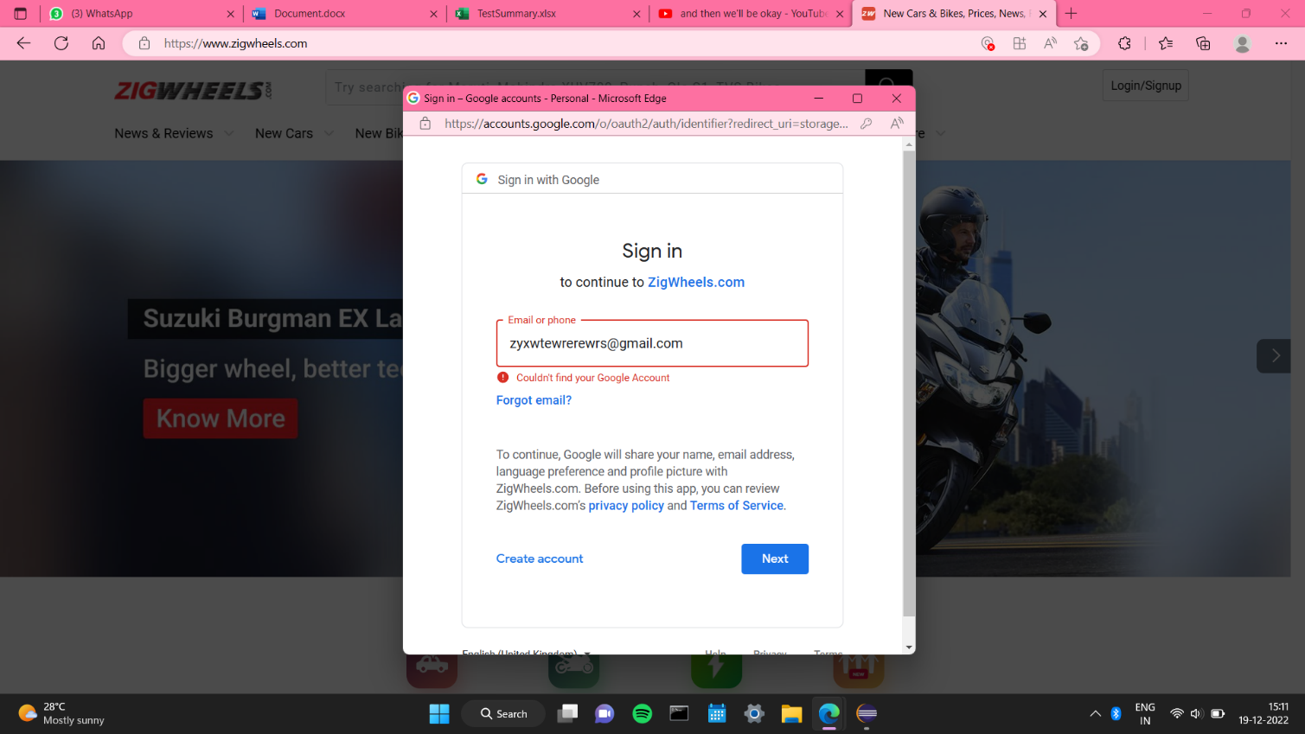

Figure 4.3.5 When user enters an unregistered email id with valid format and clicks ’Next’ button

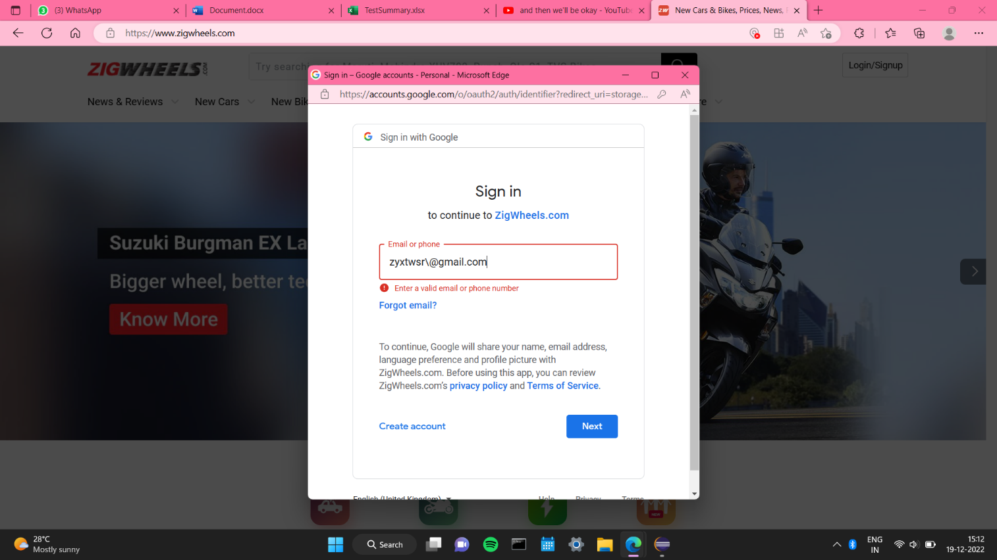

Figure 4.3.6 When user enters an invalid email id format and clicks ’Next’ button

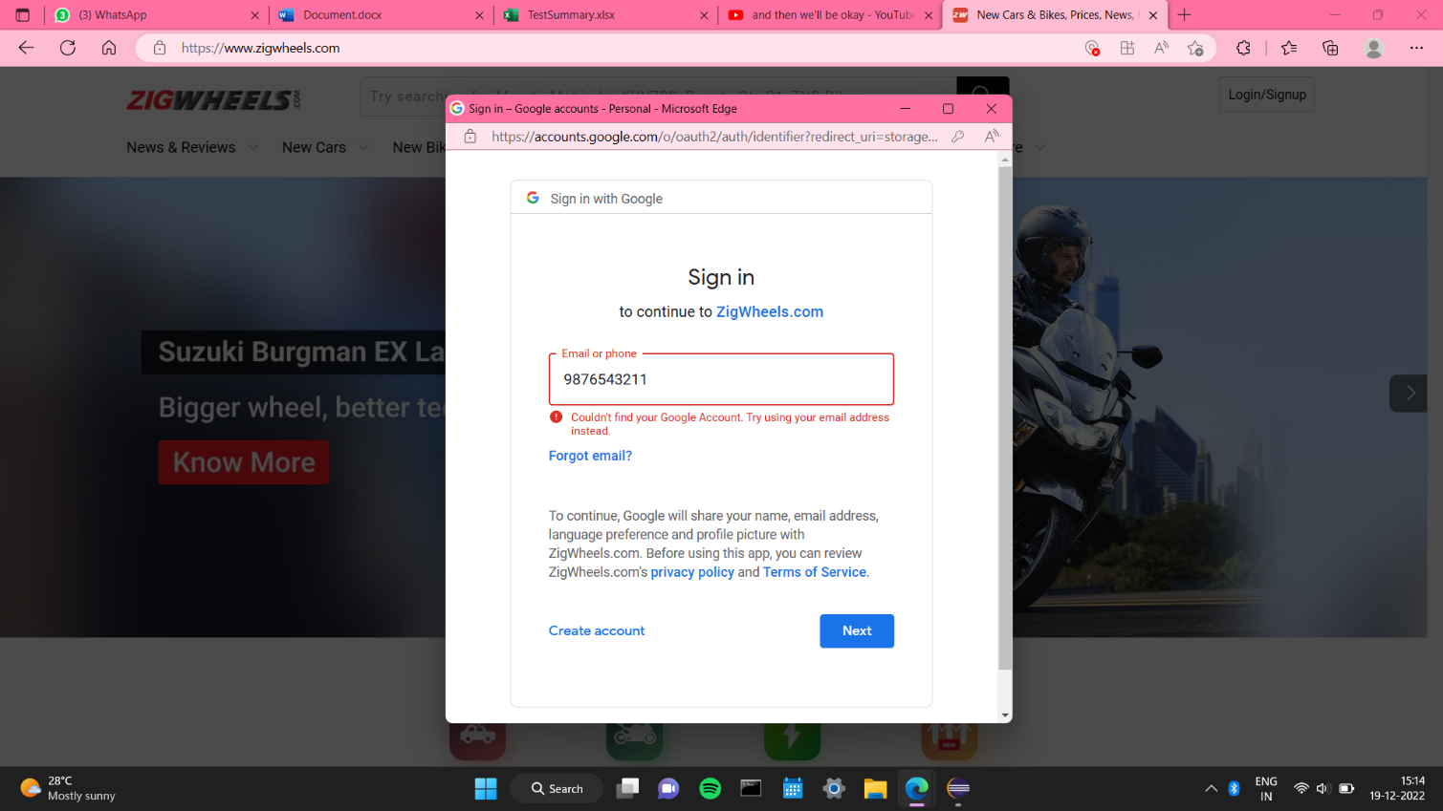

Figure 4.3.7 When user enters unregistered but valid format phone number and clicks ’Next’ button

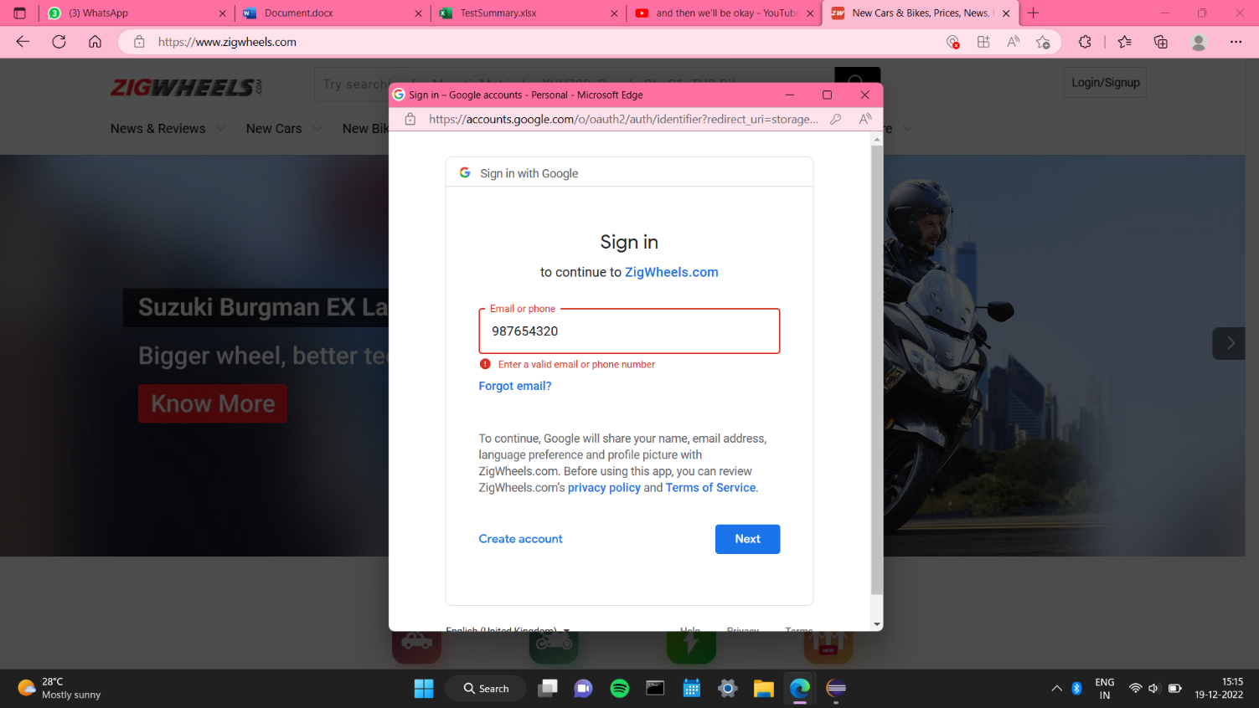

Figure 4.3.8 When user enters invalid phone number (Too short) and clicks ’Next’ button

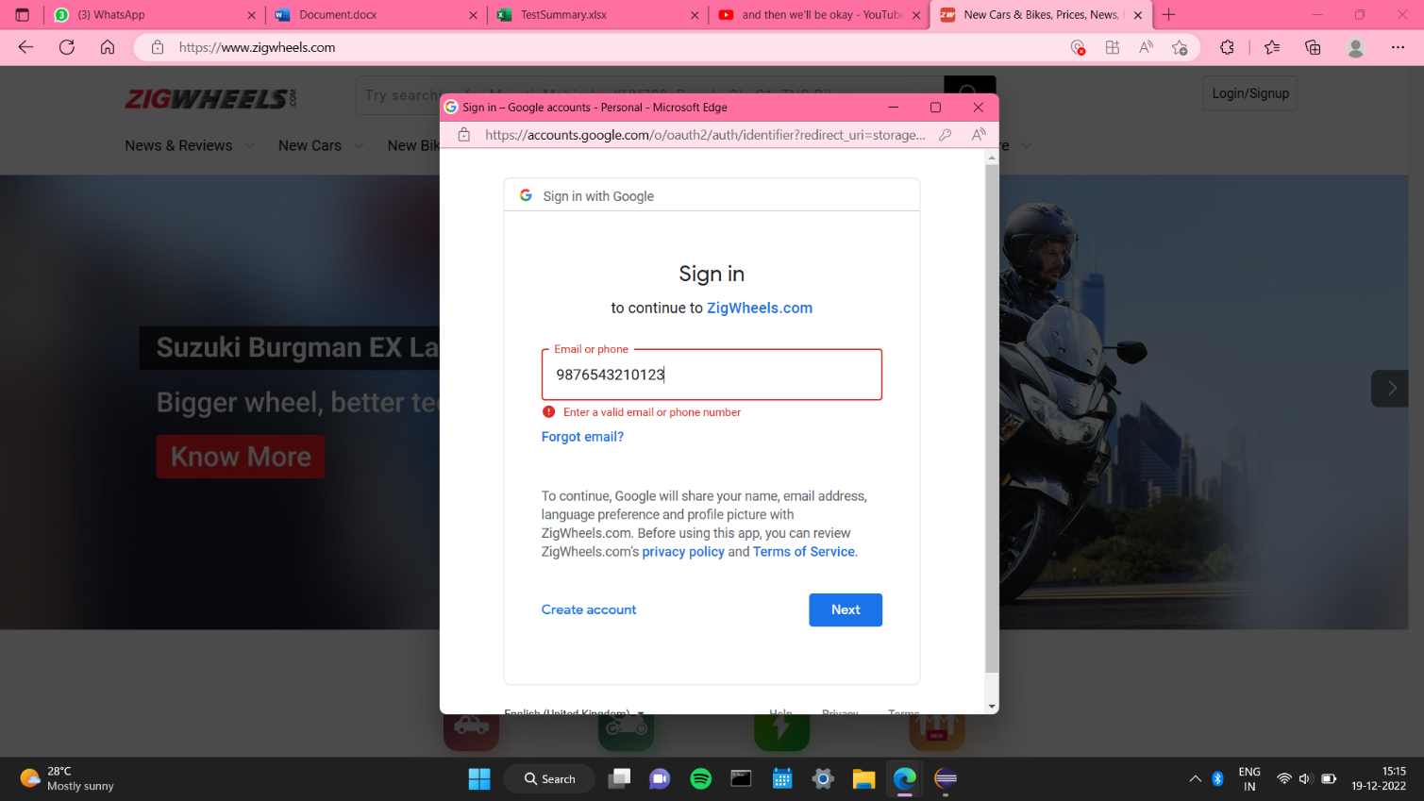

Figure 4.3.9 When user enters invalid phone number (Too long) and clicks ’Next’ button

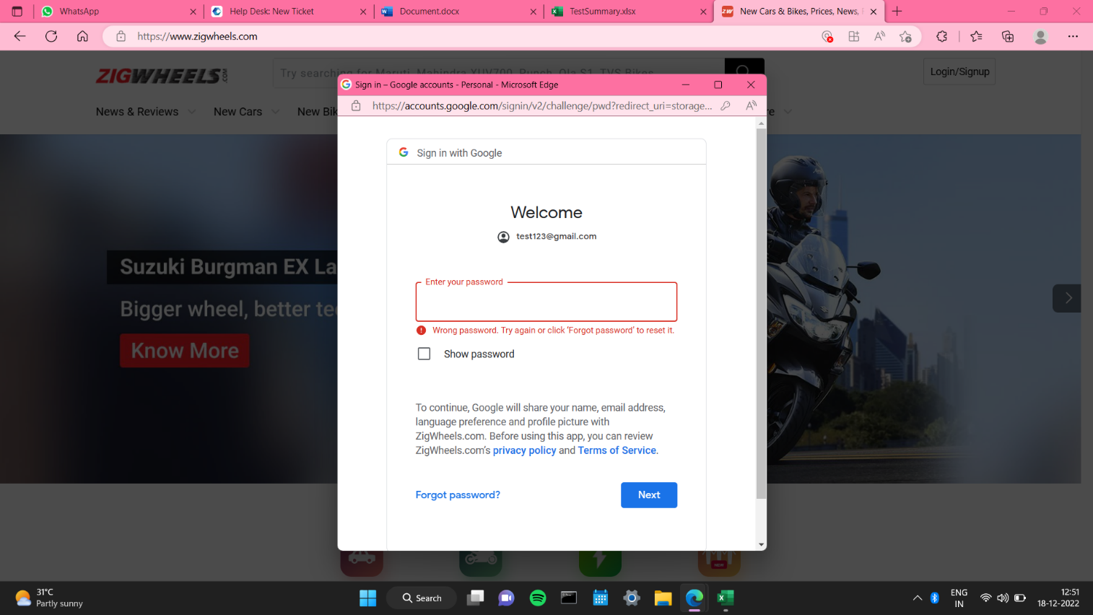

Figure 4.3.10 When user enters incorrect password and clicks ’Next’ button